**EULER GRAPH**

An Euler graph may be defined as-

|  |
| --- |
| Any connected graph is called as an Euler Graph if and only if all its vertices are of even degree.  **OR**  An Euler Graph is a connected graph that contains an Euler Circuit. |

**Euler Graph Example-**

The following graph is an example of an Euler graph-

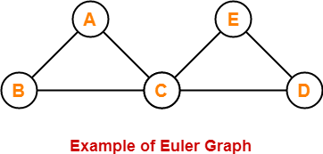

Here,

* This graph is a connected graph and all its vertices are of even degree.
* Therefore, it is an Euler graph.

Alternatively, the above graph contains an Euler circuit BACEDCB, so it is an Euler graph.

## ****Euler Path-****

Euler path is also known as **Euler Trail** or **Euler Walk**. **EVERY EDGE EXACTLY ONCE**

* If there exists a [**Trail**](https://www.gatevidyalay.com/walk-in-graph-theory/) in the connected graph that contains all the edges of the graph, then that trail is called as an Euler trail.

**OR**

* If there exists a walk in the connected graph that visits every edge of the graph exactly once with or without repeating the vertices, then such a walk is called as an Euler walk.

|  |
| --- |
| ****NOTE**** A graph will contain an Euler path if and only if it contains at most two vertices of odd degree. |

### ****Euler Path Examples-****

Examples of Euler path are as follows-

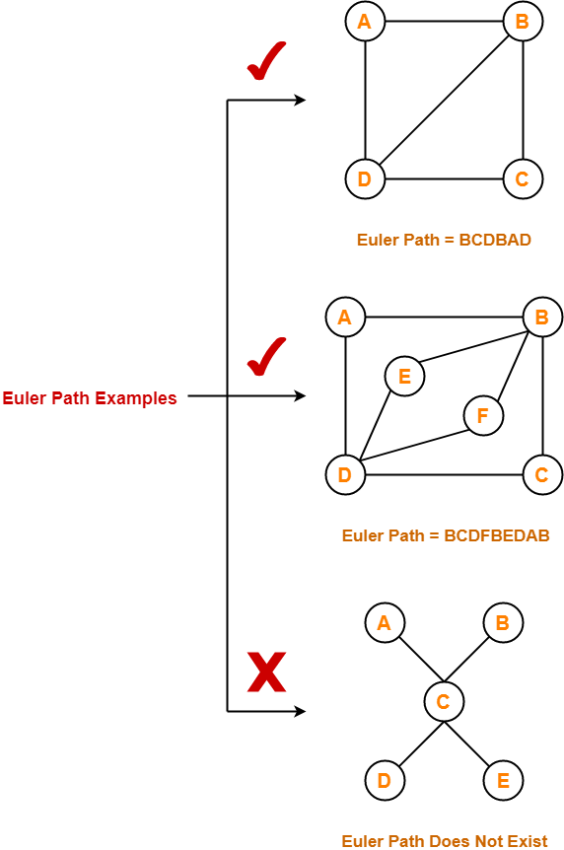

## ****Euler Circuit-****

Euler circuit is also known as **Euler Cycle** or **Euler Tour**.

* If there exists a [**Circuit**](https://www.gatevidyalay.com/walk-in-graph-theory/) in the connected graph that contains all the edges of the graph, then that circuit is called as an Euler circuit.

**OR**

* If there exists a walk in the connected graph that starts and ends at the same vertex and visits every edge of the graph exactly once with or without repeating the vertices, then such a walk is called as an Euler circuit.

**OR**

* An Euler trail that starts and ends at the same vertex is called as an Euler circuit.

**OR**

* A closed Euler trail is called as an Euler circuit.

|  |
| --- |
| ****NOTE**** A graph will contain an Euler circuit if and only if all its vertices are of even degree. |

### ****Euler Circuit Examples-****

Examples of Euler circuit are as follows-

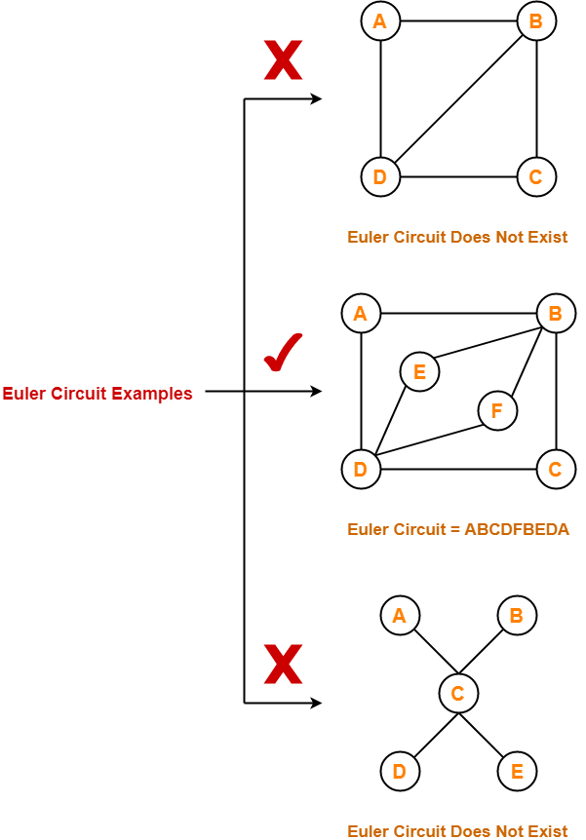

## ****Semi-Euler Graph-****

If a connected graph contains an Euler trail but does not contain an Euler circuit, then such a graph is called as a semi-Euler graph.

Thus, for a graph to be a semi-Euler graph, following two conditions must be satisfied-

* Graph must be connected.
* Graph must contain an Euler trail.

### ****Example-****

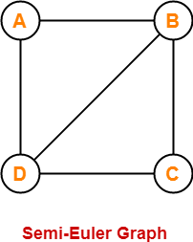

Here,

* This graph contains an Euler trail BCDBAD.
* But it does not contain an Euler circuit.
* Therefore, it is a semi-Euler graph.

**Also Read-** [**Bipartite Graph**](https://www.gatevidyalay.com/bipartite-graphs/)

## ****Important Notes-****

### ****Note-01:****

To check whether any graph is an Euler graph or not, any one of the following two ways may be used-

* If the graph is connected and contains an Euler circuit, then it is an Euler graph.
* If all the vertices of the graph are of even degree, then it is an Euler graph.

### ****Note-02:****

To check whether any graph contains an Euler circuit or not,

* Just make sure that all its vertices are of even degree.
* If all its vertices are of even degree, then graph contains an Euler circuit otherwise not.

### ****Note-03:****

To check whether any graph is a semi-Euler graph or not,

* Just make sure that it is connected and contains an Euler trail.
* If the graph is connected and contains an Euler trail, then graph is a semi-Euler graph otherwise not.

### ****Note-04:****

To check whether any graph contains an Euler trail or not,

* Just make sure that the number of vertices in the graph with odd degree are not more than 2.
* If the number of vertices with odd degree are at most 2, then graph contains an Euler trail otherwise not.

### ****Note-05:****

* A graph will definitely contain an Euler trail if it contains an Euler circuit.
* A graph may or may not contain an Euler circuit if it contains an Euler trail.

### ****Note-06:****

* An Euler graph is definitely be a semi-Euler graph.
* But a semi-Euler graph may or may not be an Euler graph.

## ****PRACTICE PROBLEMS BASED ON EULER GRAPHS IN GRAPH THEORY-****

## ****Problems-****

Which of the following is / are Euler Graphs?

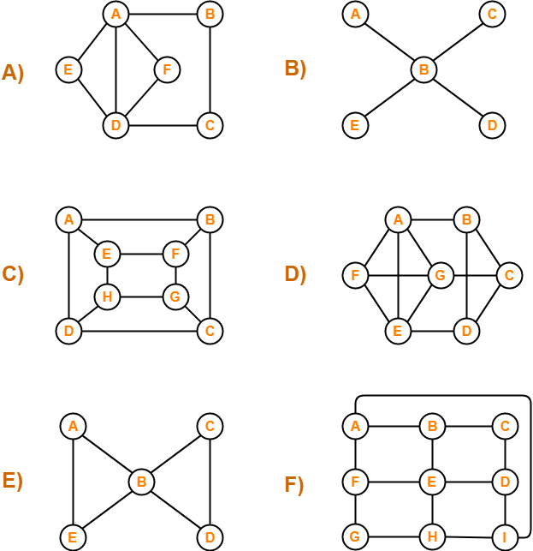

## ****Solutions-****

If all the vertices of a graph are of even degree, then graph is an Euler Graph otherwise not.

Using the above rule, we have-

**A)**It is an Euler graph.

**B)** It is not an Euler graph.

**C)** It is not an Euler graph.

**D)** It is not an Euler graph.

**E)** It is an Euler graph.